Q1. Redirect both the output and error of a command to a file

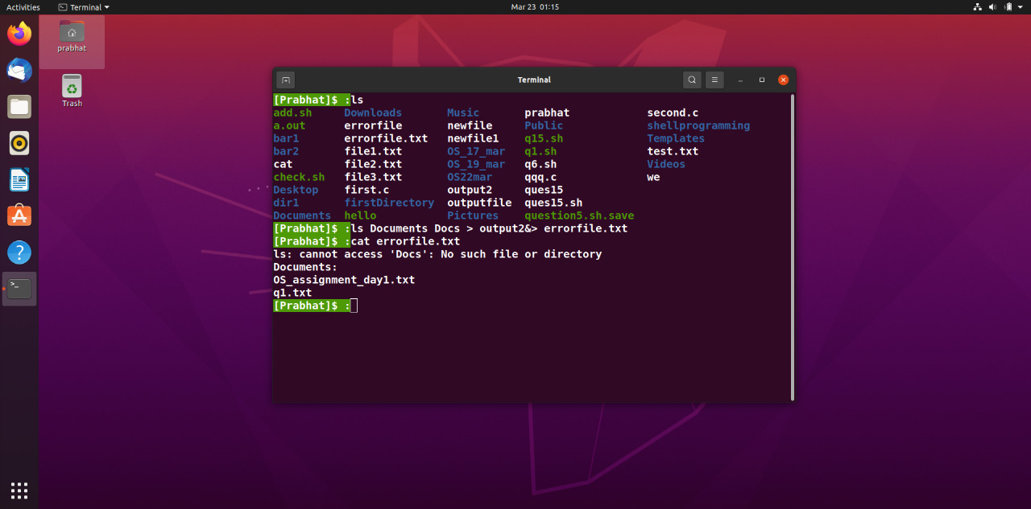

Q2. Include your current directory in the PATH environment variable using export command

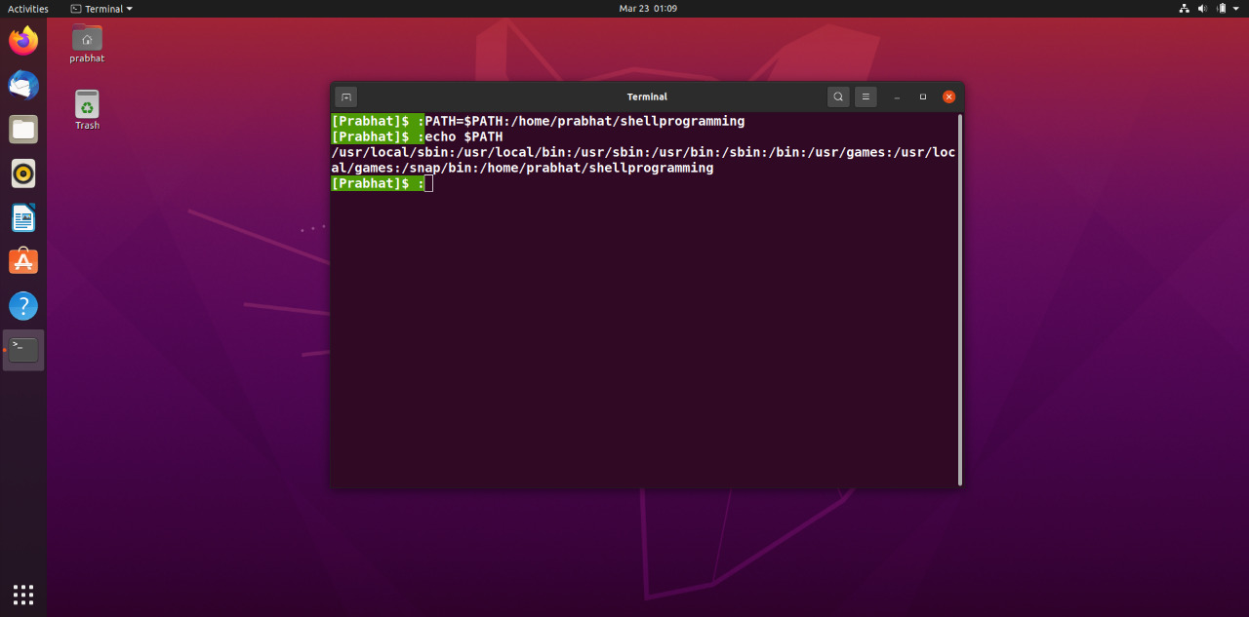

Q3. Create 2 files “file1” and “file2”. Create a directory “dir”. Copy the files to the directory and then delete the files. Do so using shell script.

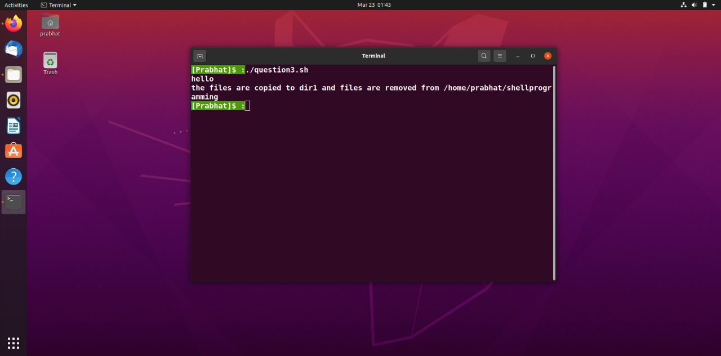

Q4. Write a script to see current date, time, username and current directory.

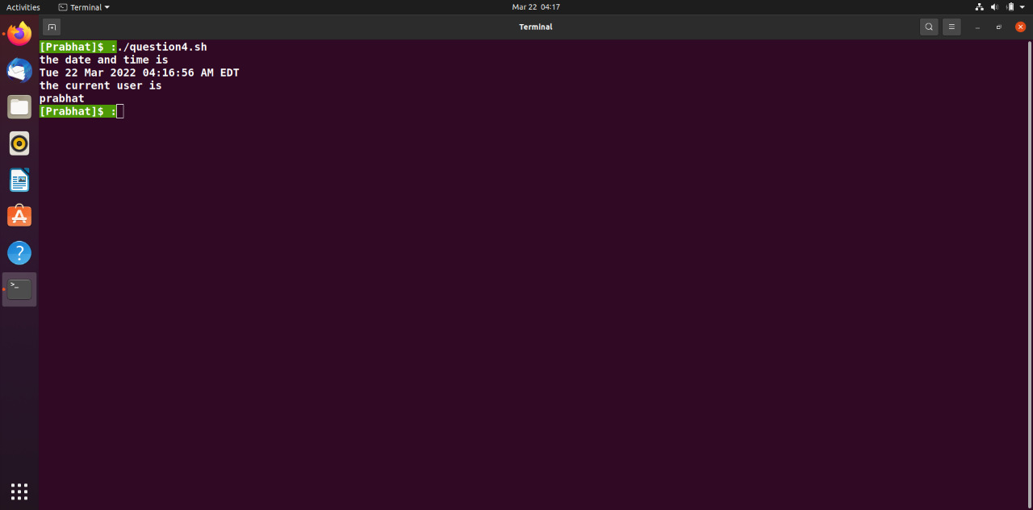

Q5. Write shell script that will add two numbers, which are supplied as command line argument

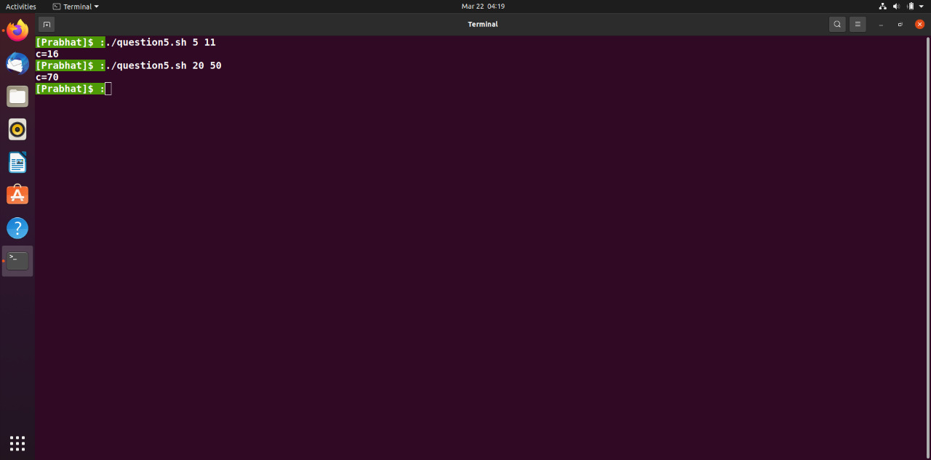

Q6. Write a script to determine whether given file exists or not, the file name is supplied as command line argument, also check for sufficient number of command line arguments.

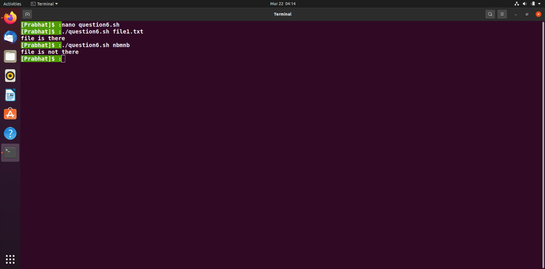

Q7. Write a script to print nos. as 5, 4, 3, 2, 1 using while loop.

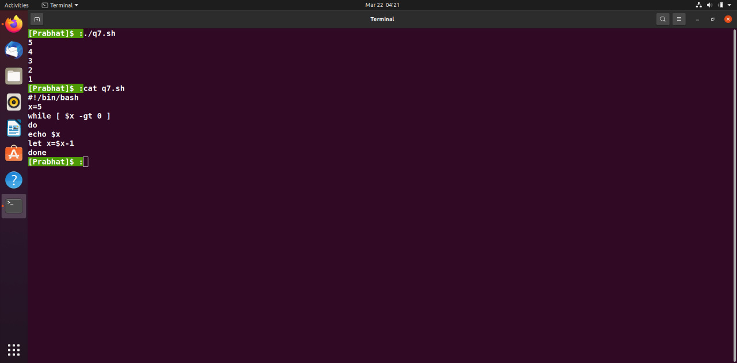

Q8. Take a number as command line and using until loop print value from 1 to till number.

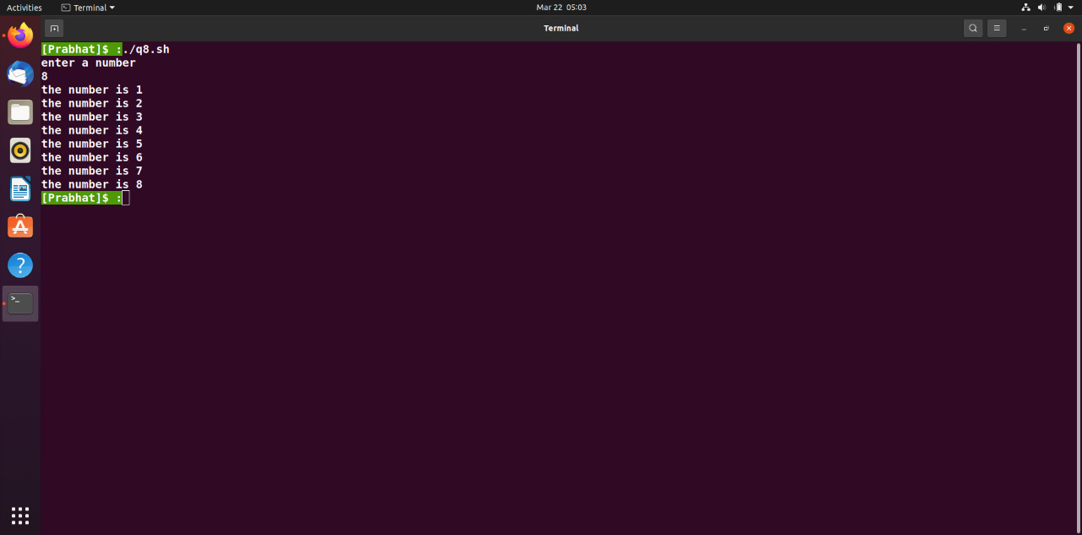

Q9. Write a script, using case statement to perform basic math operation as follows

+ addition

- subtraction

x multiplication

/ division

NOTE- two numbers will be given as command line arguments.

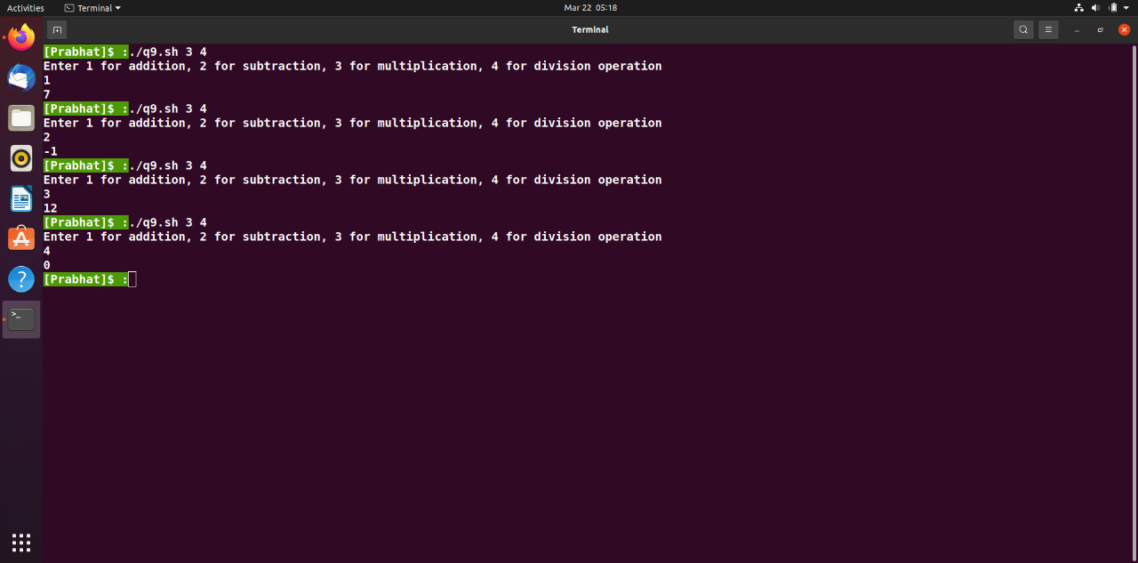

Q10. Write a script to find out biggest number from three given numbers. Numbers are supplied as command line arguments. Print error if sufficient arguments are not supplied.

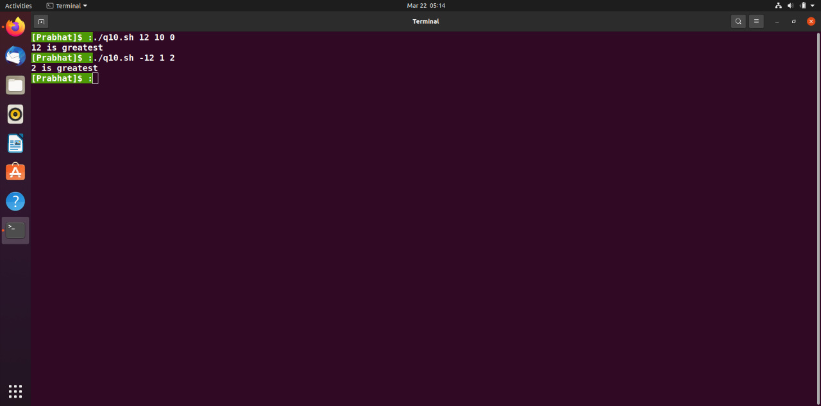

Q11. Write a program using while loop to print

0

1 0

2 1 0

3 2 1 0

4 3 2 1 0

5 4 3 2 1 0

6 5 4 3 2 1 0

7 6 5 4 3 2 1 0

8 7 6 5 4 3 2 1 0

9 8 7 6 5 4 3 2 1 0

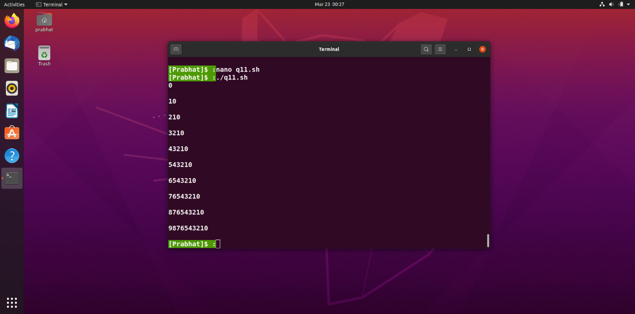

Q12. Write a program using for loop to print

\*

\*

\* \*

\* \* \*

\* \* \* \*

\* \* \* \*

\* \* \*

\* \*

\*

\* 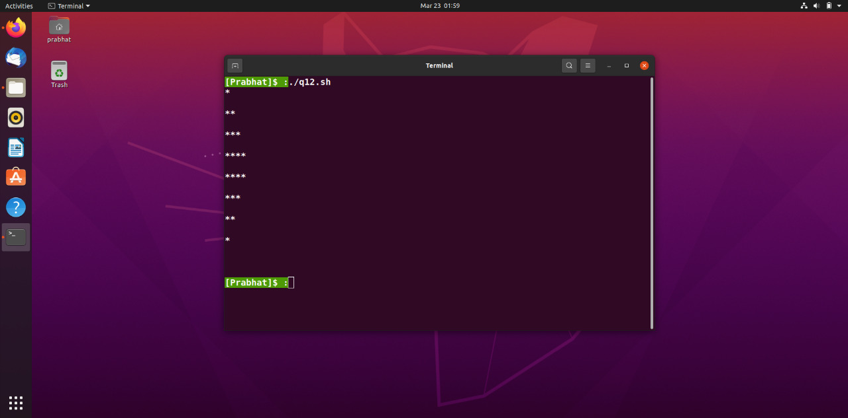

Q13. Write a script to print given number in reverse order, for eg. If number is 123, it must print as 321.

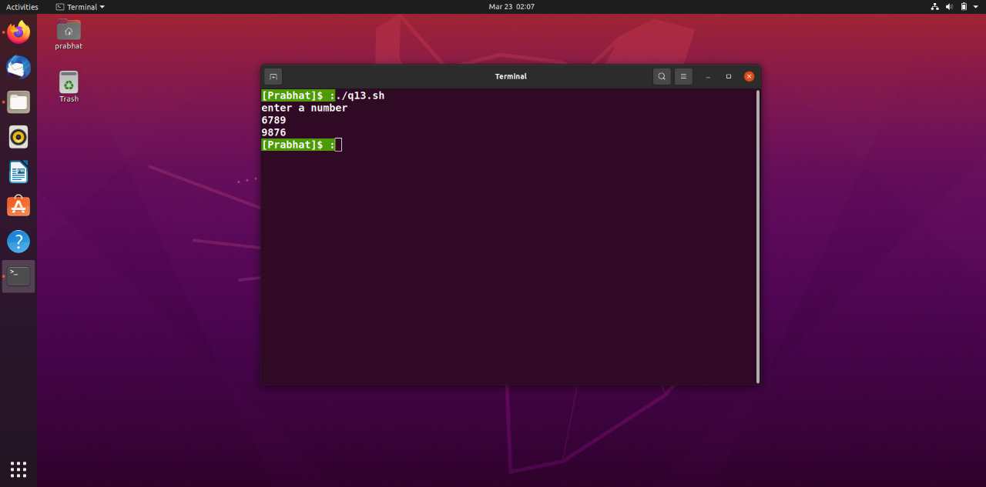

Q14. Write script to print the sum of all the digits of a given number. For eg. If the number is 123, sum

of all the digits will be 1+2+3 = 6.

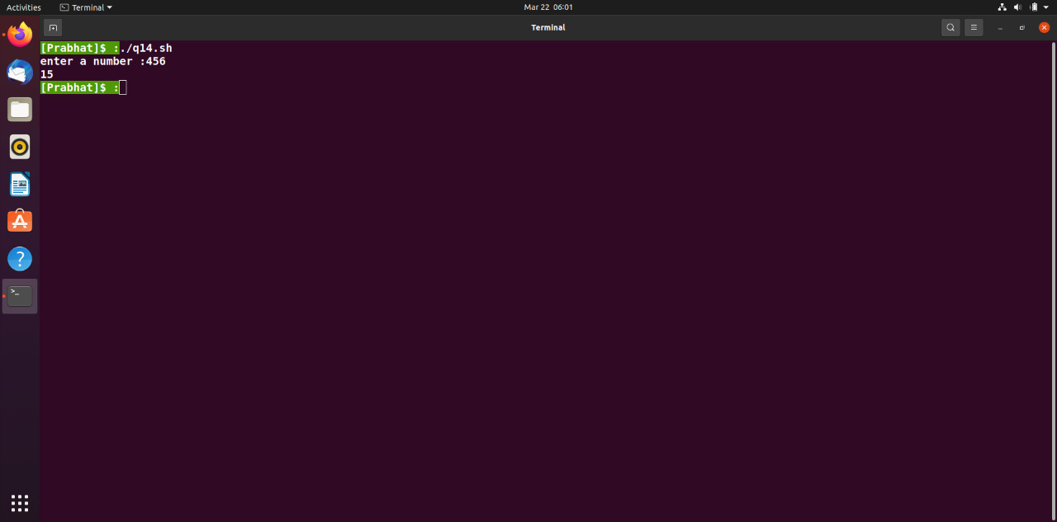

Q15. Create a file named file.txt and write a shell script to check is a file is readable , writable and

executable.

